# Advanced Challenge - Rate Variation Simulation

# Introduction

In this advanced challenge, we will extend our simulation to explore the behavior of a Poisson process with varying event rates (λ) over time. We want to observe how changes in λ impact event occurrences. To achieve this, we will simulate a Poisson process with a time-varying λ and visualize the results.

## Simulation Design

To simulate a Poisson process with varying event rates, we will define a function that generates events over a specified time interval, with λ changing at different time points. We will also use Python and the numpy and matplotlib libraries for this simulation.

1. import matplotlib.pyplot as plt
2. import numpy as np
3. # Define time interval and time points for rate variation
4. time_interval = 100 # Total time interval
5. rate_changes = [(20, 30, 30), (30, 50, 50), (50, 10, 70), (10, 5, 100)] # List of (lambda_start, lambda_end, time_point)
6. # Function to generate events with varying rates
7. def generate_events_with_varying_rate(time_interval, rate_changes):
8. event_times = [] # List to store event times
9. current_time = 0 # Initialize current time
10. for lambda_start, lambda_end, time_point in rate_changes:
11. # Generate events using the current rate (lambda_start) until the time_point
12. while current_time < time_point:
13. num_events = np.random.poisson(lambda_start)
14. event_times.extend(np.sort(np.random.uniform(current_time, time_point, num_events)))
15. current_time = time_point
16. # Update lambda to the new value (lambda_end)
17. lambda_start = lambda_end
18. # Generate events for the remaining time interval
19. while current_time < time_interval:
20. num_events = np.random.poisson(lambda_start)
21. event_times.extend(np.sort(np.random.uniform(current_time, time_interval, num_events)))
22. current_time = time_interval
23. return event_times
24. # Generate events with varying rates
25. event_times = generate_events_with_varying_rate(time_interval, rate_changes)
26. # Plot event times
27. plt.figure(figsize=(10, 6))
28. plt.title('Poisson Process with Varying Event Rates')
29. plt.eventplot(event_times, lineoffsets=0, colors='b')
30. plt.xlabel('Time')
31. plt.ylabel('Event Occurrence')
32. plt.xlim(0, time_interval)
33. plt.show()

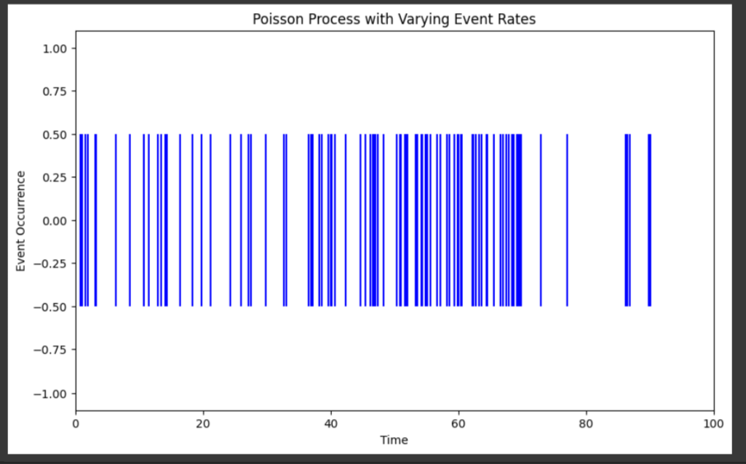

*Fig: Poisson Process with Varying Event Rates*

# **Discussion and Insights**

In this extended simulation, we introduced four different rate changes at specific time points, creating a dynamic Poisson process with varying event rates. Here are the insights:

* At the beginning (t=0), the rate is 20, resulting in a moderate number of events.
* At t=30, the rate increases to 30, leading to a higher density of events.
* At t=50, the rate increases significantly to 50, resulting in a burst of events.
* At t=70, the rate decreases to 10, and finally, at t=100, it further decreases to 5, leading to fewer events towards the end of the time interval.

These rate changes illustrate the ability to model dynamic event patterns in real-world scenarios. For example, this type of simulation could represent changing user activity on a website throughout the day, with spikes in traffic during peak hours and reduced activity during off-peak times. It could also reflect fluctuations in demand for a service over time, such as customer arrivals at a restaurant during different hours of the day.

Understanding and simulating such dynamic Poisson processes with varying event rates are crucial for making informed decisions and optimizing processes in systems where event rates change over time. It allows businesses and organizations to allocate resources efficiently and adapt to changing demand patterns.